Channel Pathways
Complete Practice Exam Question Collection
13 question banks · 130 multiple-choice questions · Includes image-based questions and explanatory feedback
Import format: Each question uses normal text numbering, four answer choices, +++++ after the correct response and feedback without answer-choice letters.

Practice Exam — Objective 1: Twelve Primary Channels
Question bank 1 of 13 · 10 questions
1) Which directional pattern identifies the Hand Yin Primary Channels?
A) They travel from the chest to the hand. +++++
B) They travel from the hand to the head.
C) They travel from the head to the foot.
D) They travel from the foot to the chest.
Feedback: The Hand Yin Primary Channels travel from the chest toward the hand. Why are the other options incorrect? They travel from the hand to the head. — Hand to head is the Hand Yang direction. They travel from the head to the foot. — Head to foot is the Foot Yang direction. They travel from the foot to the chest. — Foot to chest is the Foot Yin direction.
2) Which directional pattern identifies the Hand Yang Primary Channels?
A) Hand to head +++++
B) Head to foot
C) Foot to chest
D) Chest to hand
Feedback: The Hand Yang Primary Channels travel from the hand toward the head. Why are the other options incorrect? Head to foot — Head to foot identifies Foot Yang channels. Foot to chest — Foot to chest identifies Foot Yin channels. Chest to hand — Chest to hand identifies Hand Yin channels.
3) Which directional pattern identifies the Foot Yang Primary Channels?
A) Head to foot +++++
B) Foot to chest
C) Chest to hand
D) Hand to head
Feedback: The Foot Yang Primary Channels descend from the head toward the foot. Why are the other options incorrect? Foot to chest — Foot to chest is the Foot Yin direction. Chest to hand — Chest to hand is the Hand Yin direction. Hand to head — Hand to head is the Hand Yang direction.
4) Which directional pattern identifies the Foot Yin Primary Channels?
A) Foot to chest +++++
B) Chest to hand
C) Hand to head
D) Head to foot
Feedback: The Foot Yin Primary Channels ascend from the foot toward the chest. Why are the other options incorrect? Chest to hand — Chest to hand describes Hand Yin channels. Hand to head — Hand to head describes Hand Yang channels. Head to foot — Head to foot describes Foot Yang channels.
5) What is the anterior-to-posterior order of the three Hand Yin Primary Channels?
A) Heart, Pericardium, Lung
B) Lung, Pericardium, Heart +++++
C) Pericardium, Lung, Heart
D) Lung, Heart, Pericardium
Feedback: On the upper limb, the Hand Yin positional order is Lung anteriorly, Pericardium in the middle and Heart posteriorly. Why are the other options incorrect? Heart, Pericardium, Lung — This reverses the anterior and posterior positions. Pericardium, Lung, Heart — Pericardium is the middle route, not the anterior route. Lung, Heart, Pericardium — Heart is posterior to Pericardium, not in the middle.
6) What is the anterior-to-posterior order of the three Hand Yang Primary Channels?
A) Small Intestine, Sanjiao, Large Intestine
B) Sanjiao, Large Intestine, Small Intestine
C) Large Intestine, Small Intestine, Sanjiao
D) Large Intestine, Sanjiao, Small Intestine +++++
Feedback: The Hand Yang order is Large Intestine anteriorly, Sanjiao in the middle and Small Intestine posteriorly. Why are the other options incorrect? Small Intestine, Sanjiao, Large Intestine — This reverses Large Intestine and Small Intestine. Sanjiao, Large Intestine, Small Intestine — Sanjiao belongs in the middle rather than anteriorly. Large Intestine, Small Intestine, Sanjiao — Small Intestine is posterior, not the middle route.
7) What is the anterior-to-posterior order of the three Foot Yang Primary Channels?
A) Stomach, Gall Bladder, Bladder +++++
B) Gall Bladder, Stomach, Bladder
C) Bladder, Gall Bladder, Stomach
D) Stomach, Bladder, Gall Bladder
Feedback: The Foot Yang order is Stomach anteriorly, Gall Bladder laterally or in the middle and Bladder posteriorly. Why are the other options incorrect? Gall Bladder, Stomach, Bladder — Gall Bladder occupies the middle or lateral position, not the anterior route. Bladder, Gall Bladder, Stomach — This reverses Stomach and Bladder. Stomach, Bladder, Gall Bladder — Bladder is posterior rather than the middle route.
8) What is the anterior-to-posterior order of the three Foot Yin Primary Channels?
A) Spleen, Kidney, Liver
B) Kidney, Liver, Spleen
C) Spleen, Liver, Kidney +++++
D) Liver, Spleen, Kidney
Feedback: The Foot Yin positional map places Spleen anteriorly, Liver in the middle and Kidney posteriorly. Why are the other options incorrect? Spleen, Kidney, Liver — Kidney is posterior, not the middle route. Kidney, Liver, Spleen — This reverses the anterior and posterior positions. Liver, Spleen, Kidney — Liver belongs in the middle rather than anteriorly.
9) What is the channel shown in the image?
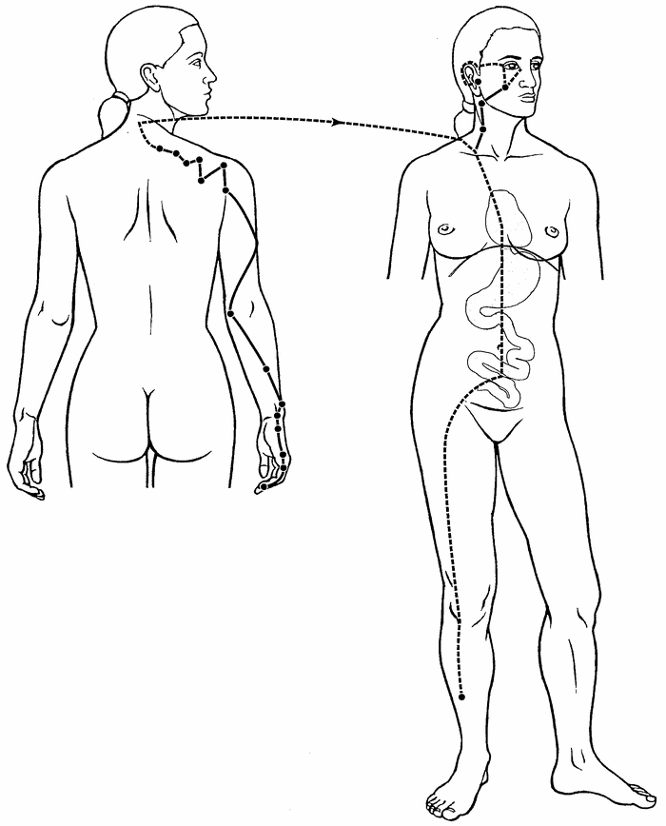
A) Small Intestine Primary Channel +++++
B) Small Intestine Sinew Channel
C) Small Intestine Divergent Channel
D) Small Intestine Luo-Connecting Channel
Feedback: The Small Intestine Primary Channel is identified by its point-bearing route from the little finger through the posterior arm and scapular region toward the face and ear. Its internal branch enters the Heart, crosses the diaphragm, reaches the Stomach and belongs to the Small Intestine. Why are the other options incorrect? Small Intestine Sinew Channel — The Sinew pathway is a broad superficial musculotendinous route with binding regions. Small Intestine Divergent Channel — The Divergent pathway is identified by deep entry and convergence with the paired Heart pathway. Small Intestine Luo-Connecting Channel — The Luo-Connecting pathway begins at SI-7 and has a more limited connecting course.
10) What is the channel shown in the image?
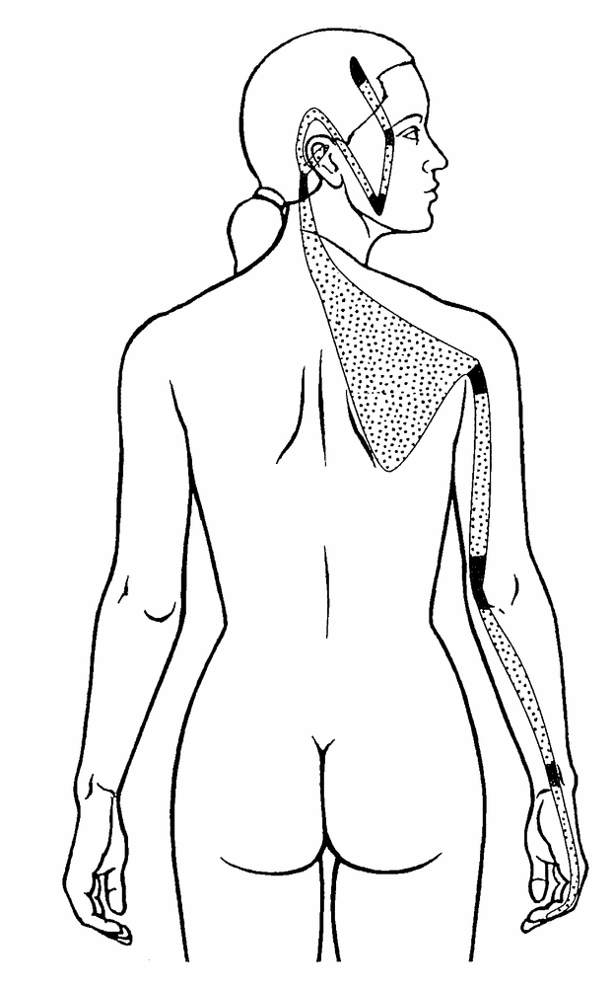
A) Small Intestine Sinew Channel +++++
B) Small Intestine Divergent Channel
C) Small Intestine Luo-Connecting Channel
D) Small Intestine Primary Channel
Feedback: The Small Intestine Sinew Channel is identified by its superficial musculotendinous route from the little finger along the posterior forearm and upper arm, with binding at the wrist and elbow, continuation across the scapular region and ascent through the neck toward the ear, jaw and outer eye. It does not enter the zangfu organs. Why are the other options incorrect? Small Intestine Divergent Channel — The Divergent Channel follows a deep internal paired-channel course. Small Intestine Luo-Connecting Channel — The Luo-Connecting Channel begins at SI-7 and does not form this broad tendon pathway. Small Intestine Primary Channel — The Primary Channel is a point-bearing reference route extending from the little finger toward the face and ear.

Practice Exam — Objective 2: Twelve Divergent Channels
Question bank 2 of 13 · 10 questions
1) Which feature most strongly identifies a Divergent Channel rather than a Primary Channel?
A) A point-by-point surface route
B) A deep route that enters zangfu and converges with a paired Yang pathway +++++
C) A branch that begins at a Luo point
D) A broad superficial route that binds at joints
Feedback: Divergent Channels are recognized by deep entry, paired zangfu relationships and convergence with a Yang pathway. Why are the other options incorrect? A point-by-point surface route — A point-bearing surface route characterizes a Primary Channel. A branch that begins at a Luo point — A branch from a Luo point characterizes a Luo-Connecting Channel. A broad superficial route that binds at joints — A broad superficial binding route characterizes a Sinew Channel.
2) What does a typical Yang Divergent Channel do after separating from its Yang Primary Channel?
A) It remains entirely superficial.
B) It begins at the paired Yin channel’s Luo point.
C) It ends at the first joint it reaches.
D) It enters the Yang organ and its paired Yin organ. +++++
Feedback: A Yang Divergent Channel typically enters both its related Yang organ and the internally–externally paired Yin organ. Why are the other options incorrect? It remains entirely superficial. — Remaining entirely superficial would omit the characteristic deep entry. It begins at the paired Yin channel’s Luo point. — Beginning at a Luo point describes Luo-Connecting organization. It ends at the first joint it reaches. — Divergent routes continue toward convergence rather than ending at the first joint.
3) How does a typical Yin Divergent Channel reconnect?
A) It returns only to its own Yin Primary Channel at the wrist or ankle.
B) It ends in a muscle binding region.
C) It forms an independent point sequence.
D) It joins the paired Yang Divergent route and then the paired Yang Primary Channel. +++++
Feedback: A Yin Divergent route connects with its paired Yang Divergent pathway and joins the paired Yang Primary Channel. Why are the other options incorrect? It returns only to its own Yin Primary Channel at the wrist or ankle. — The defining model emphasizes convergence with the paired Yang route, not only return to its own Yin channel. It ends in a muscle binding region. — Muscle binding regions are characteristic of Sinew Channels. It forms an independent point sequence. — Divergent Channels do not have independent acupuncture-point sequences.
4) Which statement about acupuncture points on Divergent Channels is correct?
A) Every Divergent point is also a Luo point.
B) Each Divergent Channel has its own numbered point sequence.
C) Only Yin Divergent Channels have numbered points.
D) Divergent Channels do not have an independent sequence of acupuncture points. +++++
Feedback: Divergent Channels are pathways associated with the Primary Channels and do not have their own independent numbered point sequence. Why are the other options incorrect? Every Divergent point is also a Luo point. — Luo points originate Luo-Connecting routes and are not synonymous with Divergent pathways. Each Divergent Channel has its own numbered point sequence. — The numbered point sequence belongs to the Primary Channel network. Only Yin Divergent Channels have numbered points. — Neither Yin nor Yang Divergent routes have an independent numbered point sequence.
5) Which sequence best summarizes Divergent Channel organization?
A) Separate, enter deeply, converge, rejoin +++++
B) Begin at a Luo point, cross to a paired channel, end superficially
C) Begin at a toe or finger, bind at joints, spread through muscles
D) Circle the waist, ascend the midline, enter the brain
Feedback: Separation, deep entry, convergence and rejoining form the core recognition sequence for Divergent Channels. Why are the other options incorrect? Begin at a Luo point, cross to a paired channel, end superficially — This sequence describes Luo-Connecting organization. Begin at a toe or finger, bind at joints, spread through muscles — This sequence describes Sinew Channel organization. Circle the waist, ascend the midline, enter the brain — This combines selected Extraordinary Vessel features rather than the Divergent model.
6) A deep branch separates near the posterior knee, relates to the Bladder and Kidney, then ascends toward the spine and nape. Which pathway is the best match?
A) Bladder Luo-Connecting Channel
B) Bladder Sinew Channel
C) Kidney Primary Channel
D) Bladder Divergent Channel +++++
Feedback: The posterior-knee separation, deep Bladder–Kidney relationship and ascent toward the spine and nape identify the Bladder Divergent pathway. Why are the other options incorrect? Bladder Luo-Connecting Channel — The Bladder Luo route begins at BL-58 and is organized as a connecting branch. Bladder Sinew Channel — The Bladder Sinew route is superficial and musculotendinous rather than a deep zangfu pathway. Kidney Primary Channel — The Kidney Primary Channel is a Foot Yin point-bearing route, not this Yang Divergent pattern.
7) A pathway from the foot and genital region joins the Gall Bladder Divergent pathway. Which channel is described?
A) Gall Bladder Sinew Channel
B) Dai Mai
C) Liver Divergent Channel +++++
D) Liver Luo-Connecting Channel
Feedback: The Liver Divergent Channel separates from the Liver Primary route, relates to the genital region and joins the paired Gall Bladder Divergent pathway. Why are the other options incorrect? Gall Bladder Sinew Channel — The Gall Bladder Sinew route is a lateral superficial body chain. Dai Mai — Dai Mai is recognized by its transverse belt-like course around the waist. Liver Luo-Connecting Channel — The Liver Luo route begins at LIV-5 and has a different connecting-pathway organization.
8) Why can Divergent Channels help explain paired Yin–Yang relationships beyond the superficial Primary routes?
A) They are defined by the color used in the diagram.
B) They enter paired zangfu and converge through the Yang pathway. +++++
C) They replace all Primary Channels.
D) They consist only of cutaneous regions.
Feedback: Deep entry into paired zangfu and convergence through a Yang route extend the internal–external relationship beyond the ordinary surface map. Why are the other options incorrect? They are defined by the color used in the diagram. — Diagram color is not a defining functional relationship. They replace all Primary Channels. — Divergent pathways supplement rather than replace Primary Channels. They consist only of cutaneous regions. — Cutaneous regions are a separate channel-system concept.
9) What is the channel shown in the image?
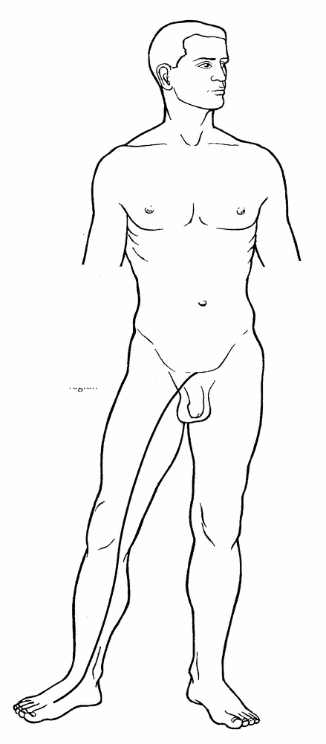
A) Liver Primary Channel
B) Liver Divergent Channel +++++
C) Liver Luo-Connecting Channel
D) Liver Sinew Channel
Feedback: The Liver Divergent Channel is identified by its ascent from the foot and medial leg toward the pubic and genital region, followed by deep convergence with the paired Gall Bladder Divergent pathway. Why are the other options incorrect? Liver Primary Channel — The Primary Channel is the ordinary point-bearing Foot Yin route. Liver Luo-Connecting Channel — The Luo-Connecting Channel begins at LIV-5 and has a characteristic genital continuation. Liver Sinew Channel — The Sinew Channel is a superficial musculotendinous pathway.
10) What is the channel shown in the image?
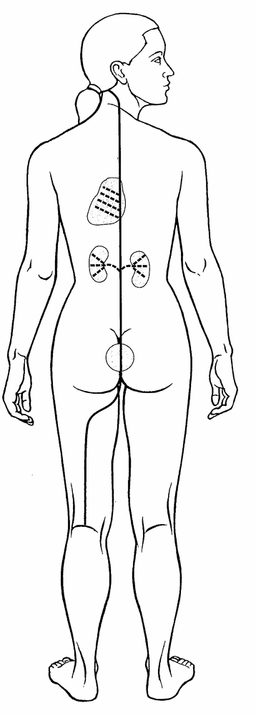
A) Bladder Luo-Connecting Channel
B) Bladder Sinew Channel
C) Bladder Primary Channel
D) Bladder Divergent Channel +++++
Feedback: The Bladder Divergent Channel separates near the popliteal region, enters deeply to connect with the Bladder and disperse through the Kidney, then ascends beside the spine toward the Heart, emerges at the neck and rejoins the Bladder Primary Channel. Why are the other options incorrect? Bladder Luo-Connecting Channel — The Luo-Connecting Channel begins at BL-58 and connects with the Kidney Channel. Bladder Sinew Channel — The Sinew Channel is a broad superficial posterior chain. Bladder Primary Channel — The Primary Channel is the ordinary point-bearing posterior pathway.

Practice Exam — Objective 3: Luo-Connecting Channels
Question bank 3 of 13 · 10 questions
1) What is the most accurate relationship between a Luo-Connecting point and a Luo-Connecting Channel?
A) They are interchangeable names for the same point.
B) The point is the named origin; the channel is the pathway that leaves it. +++++
C) The channel always begins at a Jing-Well point.
D) The point belongs to an Extraordinary Vessel.
Feedback: A Luo point is the named origin of a Luo-Connecting Channel; the channel is the branch that travels from that point. Why are the other options incorrect? They are interchangeable names for the same point. — A point and the pathway arising from it are related but not interchangeable. The channel always begins at a Jing-Well point. — Luo routes are not defined by beginning at Jing-Well points. The point belongs to an Extraordinary Vessel. — Ordinary Luo points belong to Primary Channels, not automatically to Extraordinary Vessels.
2) Which Luo-Connecting pathway begins at LI-6 and continues toward the jaw, teeth and ear?
A) Small Intestine Luo-Connecting Channel
B) Stomach Luo-Connecting Channel
C) Lung Luo-Connecting Channel
D) Large Intestine Luo-Connecting Channel +++++
Feedback: The Large Intestine Luo-Connecting Channel begins at LI-6 and has a distinctive continuation toward the jaw, teeth and ear. Why are the other options incorrect? Small Intestine Luo-Connecting Channel — The Small Intestine Luo route begins at SI-7 and is associated with the shoulder. Stomach Luo-Connecting Channel — The Stomach Luo route begins at ST-40 and continues toward the nape, head and throat. Lung Luo-Connecting Channel — The Lung Luo route begins at LU-7 and continues toward the palm and thenar region.
3) Which Luo-Connecting pathway begins at ST-40 and continues toward the nape, head and throat?
A) Spleen Luo-Connecting Channel
B) Bladder Luo-Connecting Channel
C) Gall Bladder Luo-Connecting Channel
D) Stomach Luo-Connecting Channel +++++
Feedback: The Stomach Luo-Connecting Channel begins at ST-40 and is recognized by its continuation toward the nape, head and throat. Why are the other options incorrect? Spleen Luo-Connecting Channel — The Spleen Luo route begins at SP-4 and relates to the abdomen, Stomach and intestines. Bladder Luo-Connecting Channel — The Bladder Luo route begins at BL-58 and connects with the Kidney Channel. Gall Bladder Luo-Connecting Channel — The Gall Bladder Luo route begins at GB-37 and continues toward the dorsum of the foot.
4) Which distinctive region helps identify the Liver Luo-Connecting Channel from LIV-5?
A) The thenar eminence
B) The genital region +++++
C) The posterior shoulder
D) The nape and throat
Feedback: The Liver Luo-Connecting Channel from LIV-5 has a characteristic relationship with the genital region. Why are the other options incorrect? The thenar eminence — The thenar eminence belongs to the LU-7 Luo continuation. The posterior shoulder — The posterior shoulder is more characteristic of the SI-7 Luo continuation. The nape and throat — The nape and throat are characteristic of the ST-40 Luo route.
5) Which Luo-Connecting Channel begins at GB-37 and extends toward the dorsum of the foot?
A) Gall Bladder +++++
B) Kidney
C) Sanjiao
D) Liver
Feedback: The Gall Bladder Luo-Connecting Channel begins at GB-37 and continues across the dorsum of the foot. Why are the other options incorrect? Kidney — The Kidney Luo begins at KID-4 and relates to the perineum and lumbar region. Sanjiao — The Sanjiao Luo begins at SJ-5 and has posterior-arm and chest relationships. Liver — The Liver Luo begins at LIV-5 and relates characteristically to the genital region.
6) Which Luo-Connecting Channel begins at HT-5 and has branches related to the root of the tongue and eye?
A) Pericardium
B) Small Intestine
C) Lung
D) Heart +++++
Feedback: The Heart Luo-Connecting Channel begins at HT-5 and has characteristic relationships with the Heart, tongue root and eye. Why are the other options incorrect? Pericardium — The Pericardium Luo begins at PC-6 and connects with the Sanjiao while entering the chest. Small Intestine — The Small Intestine Luo begins at SI-7 and continues toward the shoulder. Lung — The Lung Luo begins at LU-7 and continues to the palm and thenar eminence.
7) Which origin and continuation correctly describe the Kidney Luo-Connecting Channel?
A) KID-6; lateral heel and eye
B) KID-10; shoulder and scapula
C) KID-4; perineum and lumbar region +++++
D) KID-3; jaw and teeth
Feedback: The Kidney Luo-Connecting Channel begins at KID-4 and has characteristic perineal and lumbar continuations. Why are the other options incorrect? KID-6; lateral heel and eye — The lateral heel-to-eye course describes Yang Qiao Mai, not a Kidney Luo route. KID-10; shoulder and scapula — The shoulder continuation is associated with SI-7 rather than KID-10. KID-3; jaw and teeth — Jaw and teeth characterize the LI-6 Luo route, not a KID-3 route.
8) Which special Luo pathway spreads across the lateral chest from SP-21?
A) Bladder Divergent Channel
B) Great Luo of the Spleen +++++
C) Governing Vessel Luo
D) Dai Mai
Feedback: The Great Luo of the Spleen arises from SP-21 and spreads broadly across the lateral chest. Why are the other options incorrect? Bladder Divergent Channel — The Bladder Divergent is a deep paired-organ pathway, not a special Luo from SP-21. Governing Vessel Luo — The Governing Vessel Luo follows a posterior midline/back relationship. Dai Mai — Dai Mai girdles the waist and is an Extraordinary Vessel.
9) What is the channel shown in the image?
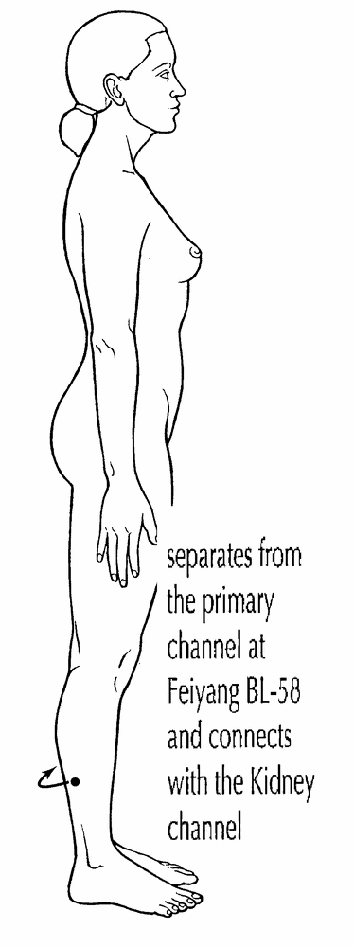
A) Bladder Luo-Connecting Channel +++++
B) Bladder Divergent Channel
C) Bladder Sinew Channel
D) Bladder Primary Channel
Feedback: The image shows a short branch leaving the Bladder Primary Channel at BL-58 on the posterolateral lower leg and connecting with the paired Kidney Channel, which identifies the Bladder Luo-Connecting Channel. Why are the other options incorrect? Bladder Divergent Channel — The Divergent Channel is a deep separation-and-convergence pathway. Bladder Sinew Channel — The Sinew Channel is a broad superficial musculotendinous chain. Bladder Primary Channel — The Primary Channel is the complete point-bearing posterior route.
10) What is the channel shown in the image?
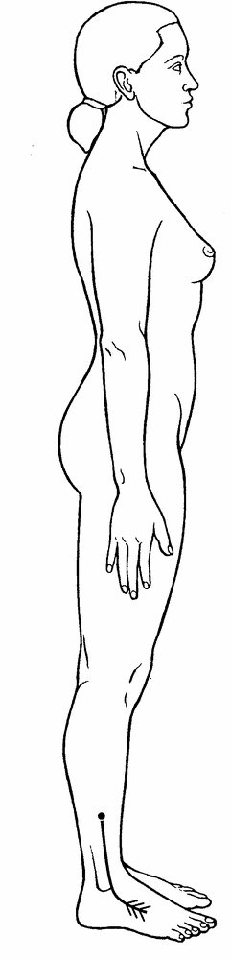
A) Gall Bladder Divergent Channel
B) Gall Bladder Sinew Channel
C) Gall Bladder Primary Channel
D) Gall Bladder Luo-Connecting Channel +++++
Feedback: The Gall Bladder Luo-Connecting Channel begins at GB-37 on the lateral lower leg, travels toward the dorsum of the foot and great toe region and connects with the paired Liver Channel. Why are the other options incorrect? Gall Bladder Divergent Channel — The Divergent Channel enters deeply and converges with the paired Liver pathway. Gall Bladder Sinew Channel — The Sinew Channel is a broad superficial lateral chain with binding regions. Gall Bladder Primary Channel — The Primary Channel is the complete point-bearing lateral pathway.

Practice Exam — Objective 4: Twelve Sinew Channels
Question bank 4 of 13 · 10 questions
1) Where do the Sinew Channels generally begin?
A) At the internal organs
B) At the extremities near fingers or toes +++++
C) At the neck
D) At the center of the abdomen
Feedback: Sinew Channels generally begin distally at finger or toe regions and ascend toward the trunk or head. Why are the other options incorrect? At the internal organs — Sinew Channels do not begin within the zangfu. At the neck — The neck may be a terminal or binding region but is not the general origin. At the center of the abdomen — The abdominal center is not the shared distal origin of the Sinew system.
2) Which feature distinguishes a Sinew Channel from a Divergent Channel?
A) Deep entry into paired zangfu
B) Rejoining a paired Yang Primary Channel after convergence
C) An independent numbered point sequence
D) A broad superficial musculotendinous route with joint bindings +++++
Feedback: Sinew Channels spread through superficial muscles and tendons and bind at joints without entering the zangfu. Why are the other options incorrect? Deep entry into paired zangfu — Deep paired-zangfu entry characterizes Divergent Channels. Rejoining a paired Yang Primary Channel after convergence — Convergence and rejoining a Yang Primary route characterize Divergent Channels. An independent numbered point sequence — Sinew Channels do not have independent numbered acupuncture-point sequences.
3) Which statement about zangfu penetration by Sinew Channels is correct?
A) Sinew Channels do not penetrate the zangfu. +++++
B) Only foot Sinew Channels enter zangfu.
C) All Sinew Channels enter their named zang organ.
D) Only Yang Sinew Channels enter zangfu.
Feedback: Sinew Channels are superficial musculotendinous pathways and do not penetrate the zangfu. Why are the other options incorrect? Only foot Sinew Channels enter zangfu. — Foot Sinew Channels also remain in the superficial musculotendinous system. All Sinew Channels enter their named zang organ. — Entering the named zang organ is not a Sinew property. Only Yang Sinew Channels enter zangfu. — Yang Sinew Channels remain superficial as well.
4) A broad pathway begins at the little toe and ascends the posterior leg and back with multiple binding regions. Which Sinew Channel is most likely?
A) Liver Sinew Channel
B) Bladder Sinew Channel +++++
C) Stomach Sinew Channel
D) Spleen Sinew Channel
Feedback: The Bladder Sinew Channel forms the broad posterior body chain from the little-toe region through the posterior leg and back. Why are the other options incorrect? Liver Sinew Channel — The Liver Sinew route is medial and has a distinct genital-region relationship. Stomach Sinew Channel — The Stomach Sinew route is predominantly anterior. Spleen Sinew Channel — The Spleen Sinew route follows the medial lower limb.
5) A broad pathway follows the anterior lower limb and anterior trunk. Which Sinew Channel should be considered first?
A) Stomach Sinew Channel +++++
B) Bladder Sinew Channel
C) Gall Bladder Sinew Channel
D) Kidney Sinew Channel
Feedback: The Stomach Sinew Channel is recognized as a broad anterior Foot Yang body chain. Why are the other options incorrect? Bladder Sinew Channel — The Bladder Sinew route is primarily posterior. Gall Bladder Sinew Channel — The Gall Bladder Sinew route is lateral. Kidney Sinew Channel — The Kidney Sinew route follows the medial Foot Yin territory.
6) Which route best characterizes the Gall Bladder Sinew Channel?
A) A medial route from the great toe into the abdomen
B) A posterior midline route beginning at the coccyx
C) A chest-to-thumb route
D) A lateral body chain from the foot toward the side of the trunk and head +++++
Feedback: The Gall Bladder Sinew Channel follows a characteristic lateral Foot Yang distribution toward the lateral trunk and head. Why are the other options incorrect? A medial route from the great toe into the abdomen — A medial great-toe route is more consistent with a Foot Yin Sinew Channel. A posterior midline route beginning at the coccyx — A posterior midline route is not the ordinary Gall Bladder Sinew course. A chest-to-thumb route — Chest to thumb describes the Lung Primary direction and territory.
7) Which Sinew Channel begins near the index finger and follows the lateral arm toward the shoulder, jaw and nose region?
A) Lung Sinew Channel
B) Pericardium Sinew Channel
C) Large Intestine Sinew Channel +++++
D) Small Intestine Sinew Channel
Feedback: The Large Intestine Sinew Channel follows the anterior Hand Yang territory from the index finger toward the shoulder and face. Why are the other options incorrect? Lung Sinew Channel — The Lung Sinew route is a Hand Yin course related to the thumb and anterior-medial arm. Pericardium Sinew Channel — The Pericardium Sinew route occupies the middle Hand Yin territory. Small Intestine Sinew Channel — The Small Intestine Sinew route begins near the little finger and follows the posterior arm and scapula.
8) Which landmarks best fit the Small Intestine Sinew Channel?
A) Middle finger, central palm and anterior chest
B) Little finger, posterior arm, scapula and ear/eye region +++++
C) Index finger, anterior-lateral arm and nose
D) Thumb, thenar region and chest
Feedback: The Small Intestine Sinew Channel is recognized by its little-finger origin and posterior arm, scapular and face distribution. Why are the other options incorrect? Middle finger, central palm and anterior chest — Middle finger and central anterior course better fit the Pericardium family. Index finger, anterior-lateral arm and nose — Index finger and nose better fit the Large Intestine family. Thumb, thenar region and chest — Thumb and chest better fit the Lung family.
9) What is the channel shown in the image?
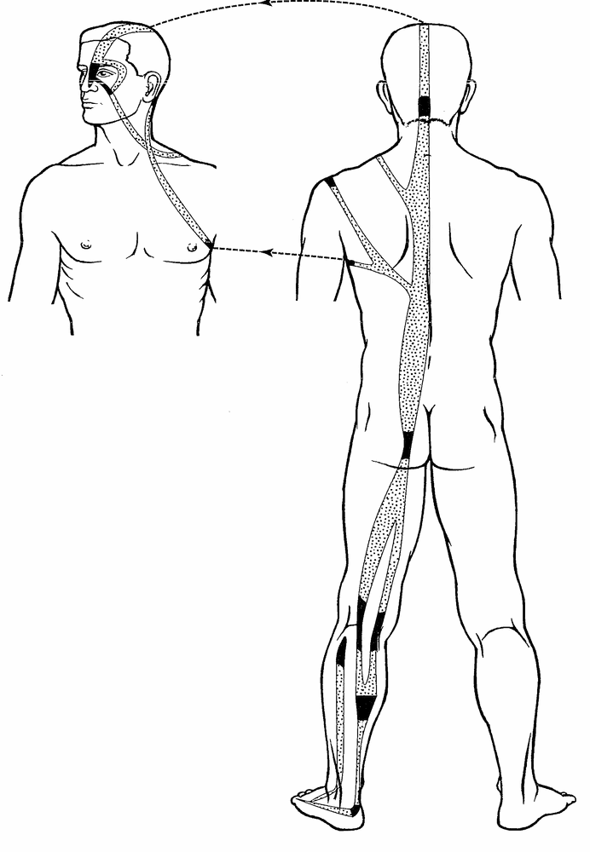
A) Bladder Sinew Channel +++++
B) Bladder Divergent Channel
C) Bladder Luo-Connecting Channel
D) Bladder Primary Channel
Feedback: The Bladder Sinew Channel is identified by its broad superficial posterior chain from the little toe and heel through the calf, popliteal region, thigh and paraspinal muscles to the neck and head, with multiple binding regions and a facial branch. It has no internal zangfu connection. Why are the other options incorrect? Bladder Divergent Channel — The Divergent Channel follows a deep internal route related to Kidney and Bladder. Bladder Luo-Connecting Channel — The Luo-Connecting Channel begins at BL-58 and forms a limited connecting branch. Bladder Primary Channel — The Primary Channel is the narrower point-bearing posterior reference pathway.
10) What is the channel shown in the image?
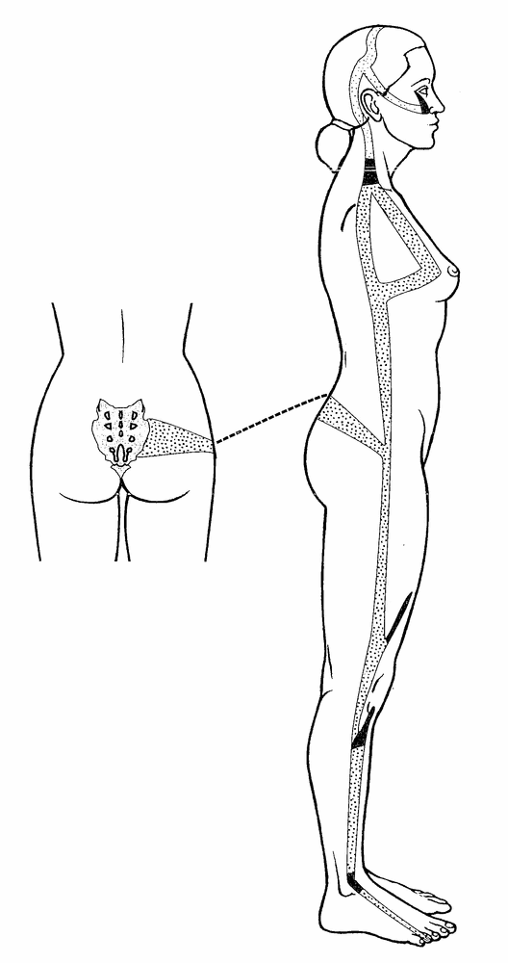
A) Gall Bladder Divergent Channel
B) Gall Bladder Luo-Connecting Channel
C) Gall Bladder Primary Channel
D) Gall Bladder Sinew Channel +++++
Feedback: The Gall Bladder Sinew Channel follows a broad superficial lateral route from the fourth toe through the lateral ankle, knee, thigh and hip, with branches to the sacral region, flank, chest, axilla and lateral head. Its muscular and joint bindings identify a Sinew pathway rather than an internal channel. Why are the other options incorrect? Gall Bladder Divergent Channel — The Divergent Channel has a deep internal convergence with the paired Liver pathway. Gall Bladder Luo-Connecting Channel — The Luo-Connecting Channel begins at GB-37 and follows a short connecting route. Gall Bladder Primary Channel — The Primary Channel is the complete point-bearing lateral route.

Practice Exam — Objective 5: Selected Extraordinary Vessels
Question bank 5 of 13 · 10 questions
1) Which vessel is recognized by a transverse, belt-like course around the waist?
A) Dai Mai +++++
B) Chong Mai
C) Yang Qiao Mai
D) Yin Wei Mai
Feedback: Dai Mai is the Girdling Vessel and is distinguished by its transverse belt-like course around the waist. Why are the other options incorrect? Chong Mai — Chong Mai has a deep central lower-abdominal and trunk distribution. Yang Qiao Mai — Yang Qiao Mai rises from the lateral heel toward the eye. Yin Wei Mai — Yin Wei Mai ascends medially toward the throat.
2) Which vessel has a deep central relationship with the lower abdomen and trunk?
A) Chong Mai +++++
B) Yang Wei Mai
C) Governing Vessel Luo
D) Dai Mai
Feedback: Chong Mai, the Penetrating Vessel, is recognized by its deep central lower-abdominal and trunk distribution. Why are the other options incorrect? Yang Wei Mai — Yang Wei Mai links lateral Yang regions. Governing Vessel Luo — The Governing Vessel Luo is a special Luo pathway, not the Chong Mai. Dai Mai — Dai Mai runs transversely around the waist.
3) Which vessel rises from the lateral heel through the lateral body toward the eye?
A) Dai Mai
B) Chong Mai
C) Yang Qiao Mai +++++
D) Yin Wei Mai
Feedback: Yang Qiao Mai, the Yang Motility Vessel, rises from the lateral heel and continues toward the eye. Why are the other options incorrect? Dai Mai — Dai Mai girdles the waist. Chong Mai — Chong Mai has a deep central distribution. Yin Wei Mai — Yin Wei Mai follows a medial lower-limb and trunk route toward the throat.
4) Which vessel links Yang regions along the lateral body, shoulder and head?
A) Dai Mai
B) Yang Wei Mai +++++
C) Yin Wei Mai
D) Chong Mai
Feedback: Yang Wei Mai, the Yang Linking Vessel, connects lateral Yang regions of the body, shoulder and head. Why are the other options incorrect? Dai Mai — Dai Mai is transverse around the waist. Yin Wei Mai — Yin Wei Mai links Yin regions along a medial pathway toward the throat. Chong Mai — Chong Mai is primarily deep and central.
5) Which vessel ascends along the medial lower limb through the abdomen and chest toward the throat?
A) Yin Wei Mai +++++
B) Yang Wei Mai
C) Yang Qiao Mai
D) Dai Mai
Feedback: Yin Wei Mai, the Yin Linking Vessel, follows a medial route through the trunk toward the throat. Why are the other options incorrect? Yang Wei Mai — Yang Wei Mai follows lateral Yang regions. Yang Qiao Mai — Yang Qiao Mai begins at the lateral heel and continues toward the eye. Dai Mai — Dai Mai encircles the waist transversely.
6) What is the best first step when identifying an Extraordinary Vessel image?
A) Select the vessel by color alone.
B) Assume every midline route is Dai Mai.
C) Look only for a numbered acupuncture point sequence.
D) Identify its overall geometry, then confirm with landmarks. +++++
Feedback: Overall geometry narrows the vessel, and specific anatomical landmarks then confirm the identification. Why are the other options incorrect? Select the vessel by color alone. — Color varies among diagrams and cannot establish identity. Assume every midline route is Dai Mai. — Dai Mai is transverse rather than simply any midline route. Look only for a numbered acupuncture point sequence. — Extraordinary Vessel recognition is not based only on an ordinary Primary Channel point sequence.
7) A diagram circles the waist horizontally. Which alternative is least consistent with that geometry?
A) Yang Qiao Mai +++++
B) The Girdling Vessel
C) Dai Mai
D) A transverse girdling pathway
Feedback: Yang Qiao Mai is least consistent because it ascends longitudinally from the lateral heel toward the eye. Why are the other options incorrect? The Girdling Vessel — The Girdling Vessel is the English name of Dai Mai. Dai Mai — Dai Mai is the correct name for the transverse route. A transverse girdling pathway — A transverse girdling pathway describes Dai Mai’s geometry.
8) Why should the Governing Vessel Luo not be classified as an Extraordinary Vessel answer in this picture bank?
A) It is one of the Twelve Primary Channels.
B) It is presented here as a special Luo pathway with a posterior midline/back distribution. +++++
C) It has no pathway.
D) It is another name for Dai Mai.
Feedback: Although the Governing Vessel is an Extraordinary Vessel, the specific image here identifies its Luo-Connecting pathway and is therefore classified as Special Luo for this exercise. Why are the other options incorrect? It is one of the Twelve Primary Channels. — The Governing Vessel is not one of the Twelve Primary Channels. It has no pathway. — The Governing Vessel Luo does have a described pathway. It is another name for Dai Mai. — Dai Mai is a different Extraordinary Vessel with a transverse waist course.
9) What is the channel shown in the image?
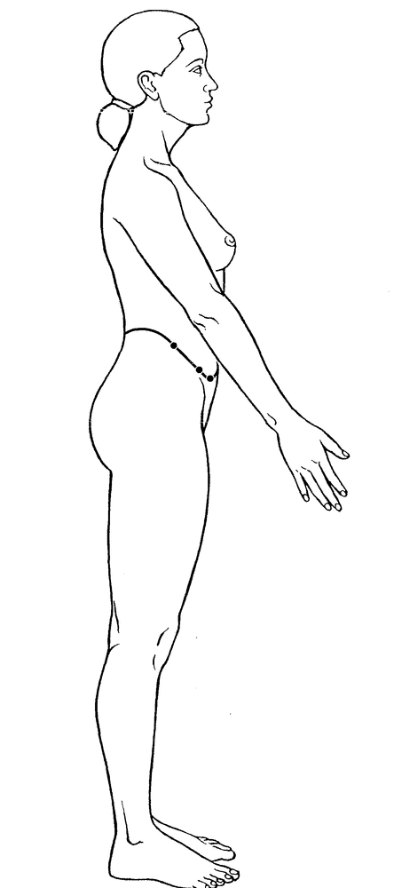
A) Girdling Vessel +++++
B) Penetrating Vessel
C) Yang Linking Vessel
D) Governing Vessel Luo
Feedback: The Girdling Vessel is identified by its unique transverse course around the waist like a belt, passing through the lateral waist region associated with GB-26, GB-27 and GB-28 rather than following a longitudinal limb-to-trunk pathway. Why are the other options incorrect? Penetrating Vessel — The Penetrating Vessel has a central ascending and abdominal distribution. Yang Linking Vessel — The Yang Linking Vessel links Yang regions and follows a different longitudinal course. Governing Vessel Luo — The Governing Vessel Luo is associated with the posterior midline and back.
10) What is the channel shown in the image?
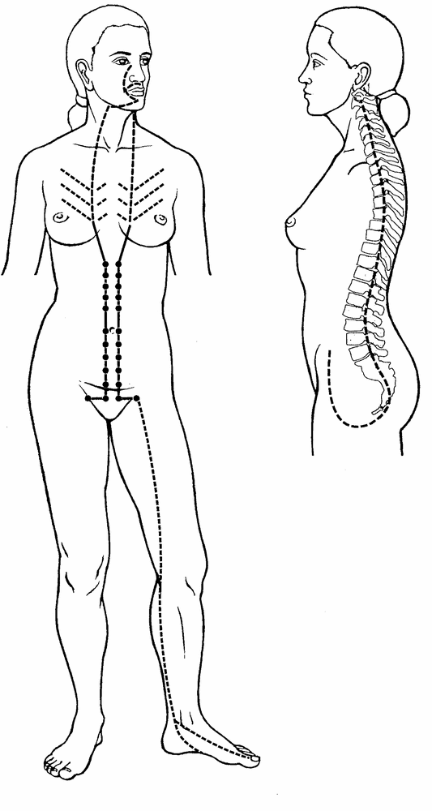
A) Girdling Vessel
B) Yang Motility Vessel
C) Yin Linking Vessel
D) Penetrating Vessel +++++
Feedback: The Penetrating Vessel arises in the lower abdomen and uterine region, emerges through the perineal area and sends an ascending branch through the abdomen and chest, with an associated posterior branch along the spine. This central distribution identifies Chong Mai. Why are the other options incorrect? Girdling Vessel — The Girdling Vessel is recognized by its transverse belt-like course around the waist. Yang Motility Vessel — The Yang Motility Vessel ascends from the lateral heel toward the eye. Yin Linking Vessel — The Yin Linking Vessel connects Yin regions through a different medial route.

Practice Exam — Objective 6: Same-Family System Comparison
Question bank 6 of 13 · 10 questions
1) A Liver image shows a point-bearing Foot Yin route with an external course from the foot toward the trunk. Which system is represented?
A) Liver Primary Channel +++++
B) Liver Divergent Channel
C) Liver Luo-Connecting Channel
D) Liver Sinew Channel
Feedback: A point-bearing Foot Yin reference route from the foot toward the trunk identifies the Liver Primary Channel. Why are the other options incorrect? Liver Divergent Channel — The Liver Divergent route is identified by deep separation and convergence with the Gall Bladder pathway. Liver Luo-Connecting Channel — The Liver Luo route begins at LIV-5 and has a characteristic genital continuation. Liver Sinew Channel — The Liver Sinew route is a broad superficial musculotendinous chain with binding regions.
2) A Liver image emphasizes deep entry and joining the paired Gall Bladder Divergent pathway. Which system is represented?
A) Liver Divergent Channel +++++
B) Liver Luo-Connecting Channel
C) Liver Sinew Channel
D) Liver Primary Channel
Feedback: Deep entry and convergence with the paired Gall Bladder pathway identify the Liver Divergent Channel. Why are the other options incorrect? Liver Luo-Connecting Channel — The Luo route begins at LIV-5 and is organized as a connecting branch. Liver Sinew Channel — The Sinew route remains superficial and binds through muscles and tendons. Liver Primary Channel — The Primary route is the ordinary point-bearing Foot Yin reference pathway.
3) A Liver image begins at LIV-5 and continues toward the genital region. Which system is represented?
A) Liver Luo-Connecting Channel +++++
B) Liver Sinew Channel
C) Liver Primary Channel
D) Liver Divergent Channel
Feedback: Origin at the named Luo point LIV-5 with a characteristic genital continuation identifies the Liver Luo-Connecting Channel. Why are the other options incorrect? Liver Sinew Channel — The Sinew route begins distally and spreads through superficial binding regions. Liver Primary Channel — The Primary route is not defined as a branch beginning at LIV-5. Liver Divergent Channel — The Divergent route is identified by deep paired-channel convergence rather than a Luo-point origin.
4) A Bladder image forms a broad superficial posterior chain with multiple joint bindings. Which system is represented?
A) Bladder Sinew Channel +++++
B) Bladder Primary Channel
C) Bladder Divergent Channel
D) Bladder Luo-Connecting Channel
Feedback: A broad superficial posterior musculotendinous chain with multiple bindings identifies the Bladder Sinew Channel. Why are the other options incorrect? Bladder Primary Channel — The Primary route is a narrower point-bearing posterior reference pathway. Bladder Divergent Channel — The Divergent route separates near the posterior knee and enters deeply in relation to Kidney and Bladder. Bladder Luo-Connecting Channel — The Luo route begins at BL-58 and connects with the Kidney Channel.
5) A Bladder pathway begins at BL-58 and connects with the Kidney Channel. Which system is represented?
A) Bladder Primary Channel
B) Bladder Luo-Connecting Channel +++++
C) Bladder Divergent Channel
D) Bladder Sinew Channel
Feedback: BL-58 is the Luo point of origin for the Bladder Luo-Connecting Channel and its paired Kidney connection. Why are the other options incorrect? Bladder Primary Channel — The Primary route does not begin at BL-58. Bladder Divergent Channel — The Divergent route is a deep separation-and-convergence pathway rather than a Luo-point branch. Bladder Sinew Channel — The Sinew route is a broad superficial posterior chain.
6) A Heart image begins at HT-5 and has branches related to the tongue root and eye. Which system is represented?
A) Heart Primary Channel
B) Heart Divergent Channel
C) Heart Sinew Channel
D) Heart Luo-Connecting Channel +++++
Feedback: HT-5 origin with tongue-root and eye relationships identifies the Heart Luo-Connecting Channel. Why are the other options incorrect? Heart Primary Channel — The Heart Primary route is the ordinary posterior Hand Yin point-bearing pathway. Heart Divergent Channel — The Heart Divergent route is organized by deep entry and paired Small Intestine convergence. Heart Sinew Channel — The Heart Sinew route is superficial and musculotendinous.
7) A Large Intestine image begins at the index finger and follows an anterior Hand Yang course toward the face. Which system is represented?
A) Large Intestine Luo-Connecting Channel
B) Large Intestine Sinew Channel
C) Large Intestine Primary Channel +++++
D) Large Intestine Divergent Channel
Feedback: The index-finger origin and ordered anterior Hand Yang course toward the face identify the Large Intestine Primary Channel. Why are the other options incorrect? Large Intestine Luo-Connecting Channel — The Luo route begins at LI-6 and continues toward jaw, teeth and ear. Large Intestine Sinew Channel — The Sinew route is broader and marked by muscular and joint bindings. Large Intestine Divergent Channel — The Divergent route is recognized by deep thoracic Lung relationship and neck convergence.
8) A Large Intestine image shows a branch from LI-6 toward the jaw, teeth and ear. Which system is represented?
A) Large Intestine Sinew Channel
B) Large Intestine Primary Channel
C) Large Intestine Divergent Channel
D) Large Intestine Luo-Connecting Channel +++++
Feedback: LI-6 origin and continuation to jaw, teeth and ear identify the Large Intestine Luo-Connecting Channel. Why are the other options incorrect? Large Intestine Sinew Channel — The Sinew route is a broad superficial binding pathway. Large Intestine Primary Channel — The Primary route begins at the index finger rather than LI-6. Large Intestine Divergent Channel — The Divergent route enters deeply toward the paired Lung relationship.
9) What is the channel shown in the image?
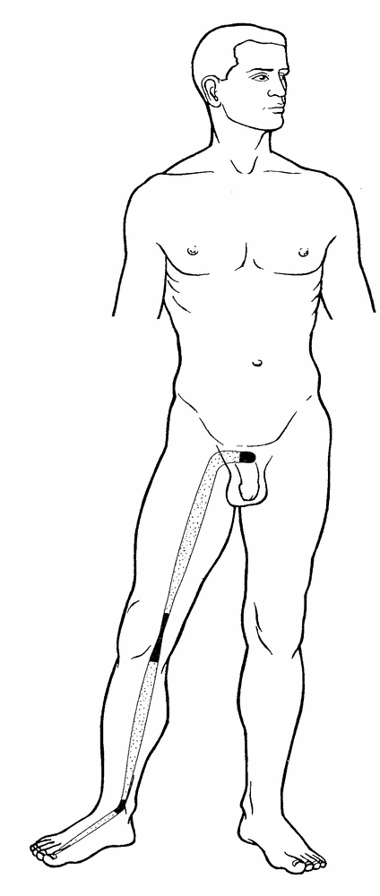
A) Liver Primary Channel
B) Liver Divergent Channel
C) Liver Luo-Connecting Channel
D) Liver Sinew Channel +++++
Feedback: The Liver Sinew Channel begins at the great toe, ascends the medial foot and leg, binds at the medial ankle and knee and continues along the medial thigh to the genital region. Its superficial musculotendinous course and binding regions distinguish it from internal Liver pathways. Why are the other options incorrect? Liver Primary Channel — The Primary Channel is the ordinary point-bearing Foot Yin route. Liver Divergent Channel — The Divergent Channel enters deeply and joins the paired Gall Bladder pathway. Liver Luo-Connecting Channel — The Luo-Connecting Channel begins at LIV-5 and has a characteristic connecting course.
10) What is the channel shown in the image?
A) Liver Divergent Channel +++++
B) Liver Luo-Connecting Channel
C) Liver Sinew Channel
D) Liver Primary Channel
Feedback: The Liver Divergent Channel ascends from the foot and medial leg toward the pubic and genital region, then follows a deep course that converges with the paired Gall Bladder Divergent pathway. Why are the other options incorrect? Liver Luo-Connecting Channel — The Luo-Connecting Channel begins at LIV-5 rather than following this deep convergence pattern. Liver Sinew Channel — The Sinew Channel remains superficial and binds through muscles and tendons. Liver Primary Channel — The Primary Channel is the external point-bearing reference route.

Practice Exam — Objective 7: Look-Alike Pathways
Question bank 7 of 13 · 10 questions
1) Which feature most clearly separates Dai Mai from a Gall Bladder Sinew route?
A) Dai Mai crosses the waist transversely. +++++
B) Dai Mai begins at a finger.
C) Gall Bladder Sinew enters paired zangfu.
D) Gall Bladder Sinew begins at a Luo point.
Feedback: The transverse belt-like waist course is the defining geometry that separates Dai Mai from a longitudinal lateral Sinew route. Why are the other options incorrect? Dai Mai begins at a finger. — Dai Mai is not identified by a finger origin. Gall Bladder Sinew enters paired zangfu. — Sinew Channels do not enter paired zangfu. Gall Bladder Sinew begins at a Luo point. — The Gall Bladder Sinew route is not defined by a Luo-point origin.
2) Which feature best separates Yang Qiao Mai from a Gall Bladder Sinew route?
A) A broad series of muscular binding regions
B) Origin at GB-37
C) Deep paired-organ convergence
D) A lateral heel-to-eye ascent +++++
Feedback: Yang Qiao Mai is recognized by its characteristic ascent from the lateral heel toward the eye. Why are the other options incorrect? A broad series of muscular binding regions — Broad muscular bindings favor a Sinew route. Origin at GB-37 — GB-37 is the origin of the Gall Bladder Luo route. Deep paired-organ convergence — Deep paired-organ convergence favors a Divergent route.
3) A posterior route includes a point-bearing external pathway and selected internal branches. Which Bladder system fits better than the broad posterior Sinew chain?
A) Bladder Luo-Connecting Channel
B) Bladder Divergent Channel
C) Bladder Primary Channel +++++
D) Bladder Sinew Channel
Feedback: A point-bearing posterior external route with internal branches identifies the Bladder Primary Channel. Why are the other options incorrect? Bladder Luo-Connecting Channel — The Luo route begins at BL-58 and connects with Kidney. Bladder Divergent Channel — The Divergent route separates and enters deeply before convergence. Bladder Sinew Channel — The Sinew route is broad, superficial and marked by bindings rather than a point sequence.
4) A posterior route separates near the knee, enters deeply in relation to Kidney and Bladder, and ascends toward the nape. Which route is it?
A) Bladder Divergent Channel +++++
B) Bladder Primary Channel
C) Bladder Sinew Channel
D) Bladder Luo-Connecting Channel
Feedback: Posterior-knee separation, deep paired-organ entry and ascent toward the nape identify the Bladder Divergent Channel. Why are the other options incorrect? Bladder Primary Channel — The Primary route is the ordinary point-bearing reference pathway. Bladder Sinew Channel — The Sinew route remains superficial and binds across the posterior body. Bladder Luo-Connecting Channel — The Luo route begins at BL-58 rather than separating deeply near the knee.
5) Which feature separates the Great Luo of the Spleen from Dai Mai?
A) It spreads across the lateral chest from SP-21. +++++
B) It circles the waist transversely.
C) It rises from the lateral heel to the eye.
D) It follows a Foot Yang point sequence.
Feedback: The Great Luo of the Spleen spreads from SP-21 across the lateral chest rather than girdling the waist. Why are the other options incorrect? It circles the waist transversely. — A transverse waist course identifies Dai Mai. It rises from the lateral heel to the eye. — Lateral heel to eye identifies Yang Qiao Mai. It follows a Foot Yang point sequence. — The Great Luo is not a Foot Yang Primary point sequence.
6) Which evidence prevents every short branch from being labeled a Luo-Connecting Channel?
A) A Luo route must always circle the waist.
B) A Luo route always enters both paired zangfu.
C) A Luo route must bind at every joint.
D) A Luo route should have a named Luo-point origin and characteristic connection or destination. +++++
Feedback: Luo identification requires the characteristic Luo-point origin and connecting destination, not merely the presence of a branch. Why are the other options incorrect? A Luo route must always circle the waist. — Circling the waist identifies Dai Mai. A Luo route always enters both paired zangfu. — Entering paired zangfu is a Divergent feature. A Luo route must bind at every joint. — Multiple joint bindings are Sinew features.
7) Which clue best distinguishes a Primary route from a Sinew route when both occupy a similar limb surface?
A) Long title versus short title
B) Presence versus absence of an organ name
C) Ordered point-bearing line and internal branches versus broad muscular bindings +++++
D) Red line versus blue line
Feedback: The Primary system uses an ordered point-bearing reference course, while the Sinew system shows broad superficial binding regions. Why are the other options incorrect? Long title versus short title — Title length has no anatomical meaning. Presence versus absence of an organ name — Both systems may share the same organ-family name. Red line versus blue line — Color is not standardized across diagrams.
8) A lateral route links Yang regions of the shoulder and head but does not girdle the waist. Which vessel is the better fit?
A) Liver Luo-Connecting Channel
B) Yang Wei Mai +++++
C) Dai Mai
D) Great Luo of the Spleen
Feedback: Yang Wei Mai links lateral Yang regions, including shoulder and head, without the transverse belt course of Dai Mai. Why are the other options incorrect? Liver Luo-Connecting Channel — The Liver Luo begins at LIV-5 and continues toward the genital region. Dai Mai — Dai Mai is transverse around the waist. Great Luo of the Spleen — The Great Luo spreads across the lateral chest from SP-21.
9) What is the channel shown in the image?
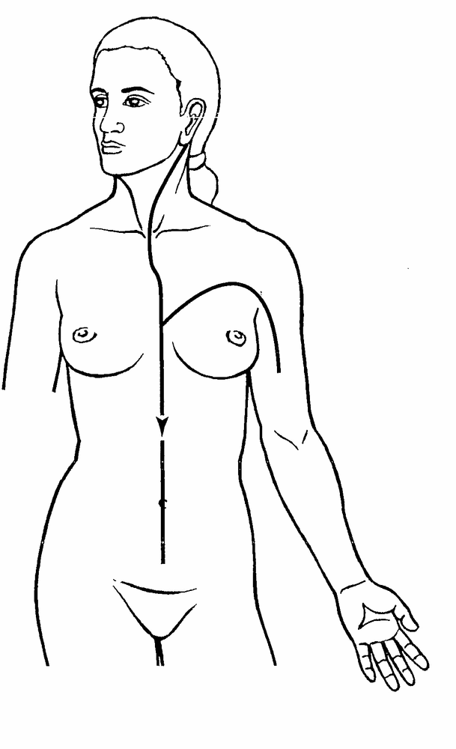
A) Pericardium Primary Channel
B) Pericardium Divergent Channel +++++
C) Pericardium Luo-Connecting Channel
D) Pericardium Sinew Channel
Feedback: The Pericardium Divergent Channel separates below the axilla, enters the chest and relates internally to the three jiao, then ascends through the throat and emerges behind the ear to join the paired Sanjiao pathway. Why are the other options incorrect? Pericardium Primary Channel — The Primary Channel is the point-bearing chest-to-hand route. Pericardium Luo-Connecting Channel — The Luo-Connecting Channel begins at PC-6 and follows a more limited connecting course. Pericardium Sinew Channel — The Sinew Channel is superficial and musculotendinous.
10) What is the channel shown in the image?
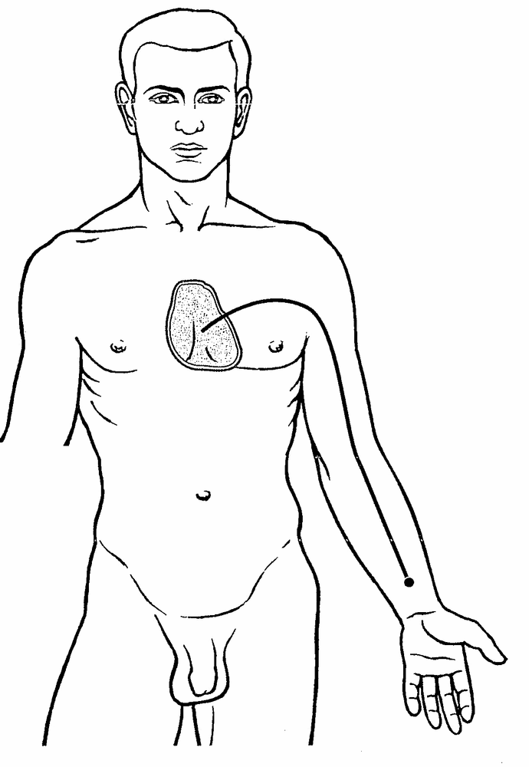
A) Pericardium Divergent Channel
B) Pericardium Luo-Connecting Channel +++++
C) Pericardium Sinew Channel
D) Pericardium Primary Channel
Feedback: The Pericardium Luo-Connecting Channel begins at PC-6 on the forearm, connects with the paired Sanjiao Channel and ascends with the Pericardium pathway into the chest to reach the Pericardium and connect with the Heart. Why are the other options incorrect? Pericardium Divergent Channel — The Divergent Channel is recognized by deeper paired-channel convergence. Pericardium Sinew Channel — The Sinew Channel forms a superficial musculotendinous route. Pericardium Primary Channel — The Primary Channel is the complete point-bearing chest-to-hand pathway.

Practice Exam — Objective 8: Mixed-Image Evidence and Justification
Question bank 8 of 13 · 10 questions
1) Which response provides the strongest identification evidence?
A) “It is Liver because the line is green.”
B) “It is Liver Luo because it begins at LIV-5 and continues toward the genital region.” +++++
C) “It is probably Liver because it is on the leg.”
D) “It is Luo because the line is short.”
Feedback: The Liver Luo response names the system and supports it with both a Luo-point origin and a characteristic destination. Why are the other options incorrect? “It is Liver because the line is green.” — Color alone is unreliable and does not identify the system. “It is probably Liver because it is on the leg.” — Many channels travel on the leg, and the organ name alone is insufficient. “It is Luo because the line is short.” — A short line is not enough to prove a Luo origin or connection.
2) What is the correct order for analyzing an unfamiliar pathway image?
A) Classify the system, locate the surface, trace the route, confirm a signature clue. +++++
B) Find one familiar region, ignore the rest, choose the closest name.
C) Identify a point number, assume Primary, stop.
D) Name the organ, choose a color, count labels, guess.
Feedback: System classification, body-surface location, full-route tracing and signature confirmation provide a repeatable evidence-based sequence. Why are the other options incorrect? Find one familiar region, ignore the rest, choose the closest name. — One familiar region can be shared by several pathways. Identify a point number, assume Primary, stop. — A visible point number does not justify ignoring the rest of the route. Name the organ, choose a color, count labels, guess. — Organ and color do not establish system identity.
3) An image shows a little-finger origin, posterior arm, scapula and face/ear course. What is the strongest justified answer?
A) Small Intestine Sinew Channel because every posterior line is Sinew.
B) Sanjiao Luo because it reaches the head.
C) Small Intestine Primary Channel because the direction and two landmarks match. +++++
D) Heart Primary Channel because both reach the little finger.
Feedback: Little-finger origin together with posterior arm, scapular and face/ear landmarks supports the Small Intestine Primary route. Why are the other options incorrect? Small Intestine Sinew Channel because every posterior line is Sinew. — A posterior line is not automatically Sinew; broad bindings would be required. Sanjiao Luo because it reaches the head. — Reaching the head alone does not identify a Sanjiao Luo route. Heart Primary Channel because both reach the little finger. — Heart is Hand Yin and travels from chest to little finger rather than hand to head.
4) An image shows a broad superficial chain with several joint bindings and no deep zangfu entry. Which evidence statement is best?
A) It is Luo because it crosses a joint.
B) It is Sinew because superficial spread and joint bindings define that system. +++++
C) It is Divergent because it has many branches.
D) It is Primary because it is long.
Feedback: Broad superficial spread and multiple joint bindings are two independent features supporting a Sinew identification. Why are the other options incorrect? It is Luo because it crosses a joint. — Crossing a joint does not prove Luo origin or connection. It is Divergent because it has many branches. — Branching alone does not establish deep Divergent organization. It is Primary because it is long. — Length alone does not establish a Primary route.
5) An image shows a transverse band around the waist. Which justification is strongest?
A) Dai Mai because its overall geometry is transverse and girdles the waist. +++++
B) Yang Wei Mai because both include Yang in the name.
C) Gall Bladder Sinew because it is lateral.
D) Great Luo of the Spleen because it is broad.
Feedback: The transverse belt-like geometry and waist location together identify Dai Mai. Why are the other options incorrect? Yang Wei Mai because both include Yang in the name. — Yang Wei is longitudinal and links lateral Yang regions. Gall Bladder Sinew because it is lateral. — Gall Bladder Sinew follows a longitudinal lateral body chain. Great Luo of the Spleen because it is broad. — The Great Luo spreads across the lateral chest from SP-21.
6) What should be done when a likely answer is supported by only one landmark?
A) Choose it immediately.
B) Use the line color as the second clue.
C) Ignore the terminal region.
D) Confirm a second independent landmark or system feature before finalizing. +++++
Feedback: A second independent clue reduces errors caused by overlapping body regions and incomplete drawings. Why are the other options incorrect? Choose it immediately. — Immediate selection from one clue is vulnerable to look-alike routes. Use the line color as the second clue. — Color is not reliable independent evidence. Ignore the terminal region. — The terminal region may provide the needed confirmation.
7) How should a learner explain rejection of the closest distractor?
A) Refer only to option order.
B) Use the date of the image.
C) Name the missing or contradictory system feature. +++++
D) Say only that it looks wrong.
Feedback: Naming the missing or contradictory feature demonstrates why the alternative fails the same evidence test. Why are the other options incorrect? Refer only to option order. — Option order is unrelated to pathway anatomy. Use the date of the image. — Image date does not distinguish channel systems. Say only that it looks wrong. — Appearance without evidence does not justify elimination.
8) A source image omits an expected internal branch but matches the external course. What is the best conclusion?
A) Discard all other sources.
B) Treat the identification as provisional and compare a complete reference. +++++
C) Conclude the branch does not exist.
D) Automatically reclassify it as Sinew.
Feedback: A provisional identification followed by source comparison accounts for selective educational diagrams without inventing certainty. Why are the other options incorrect? Discard all other sources. — Source comparison is more appropriate than rejecting all other references. Conclude the branch does not exist. — Omission in one image is not proof that a branch does not exist. Automatically reclassify it as Sinew. — Missing detail alone does not establish Sinew organization.
9) What is the channel shown in the image?
A) Small Intestine Primary Channel +++++
B) Small Intestine Sinew Channel
C) Small Intestine Divergent Channel
D) Small Intestine Luo-Connecting Channel
Feedback: The image is identified as the Small Intestine Primary Channel by its little-finger origin and posterior arm and scapular course toward the face and ear. Its internal branch enters the Heart, crosses the diaphragm, reaches the Stomach and belongs to the Small Intestine. Why are the other options incorrect? Small Intestine Sinew Channel — The Sinew Channel is broader and organized through superficial binding regions. Small Intestine Divergent Channel — The Divergent Channel is identified by deep entry and paired Heart convergence. Small Intestine Luo-Connecting Channel — The Luo-Connecting Channel begins at SI-7 and follows a shorter connecting course.
10) What is the channel shown in the image?
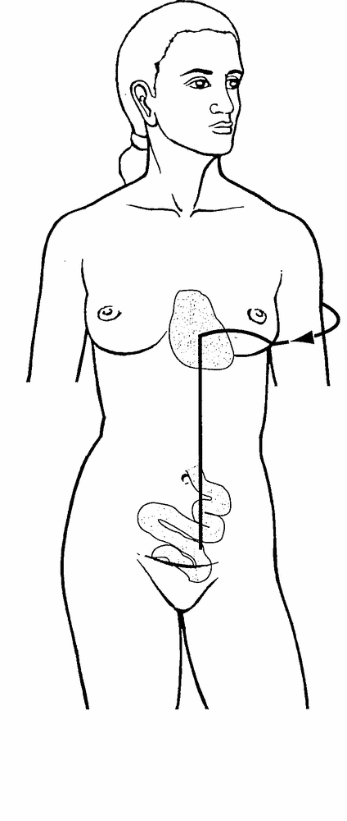
A) Small Intestine Sinew Channel
B) Small Intestine Divergent Channel +++++
C) Small Intestine Luo-Connecting Channel
D) Small Intestine Primary Channel
Feedback: The Small Intestine Divergent Channel separates near the shoulder, enters the axilla, crosses the Heart and descends through the diaphragm into the abdomen to connect with the Small Intestine. This deep internal route and paired Heart relationship distinguish it from the surface Primary, Sinew and Luo pathways. Why are the other options incorrect? Small Intestine Sinew Channel — The Sinew Channel is superficial and musculotendinous. Small Intestine Luo-Connecting Channel — The Luo-Connecting Channel begins at SI-7 and follows a limited connecting branch. Small Intestine Primary Channel — The Primary Channel is the external point-bearing route from the little finger toward the face and ear.

Practice Exam — Objective 9: Anatomical Region Organization
Question bank 9 of 13 · 10 questions
1) What is the first step in region-first pathway analysis?
A) List every pathway documented for the selected anatomical area. +++++
B) Choose the organ name that appears most familiar.
C) Identify the color used most often.
D) Assume every route in the area belongs to one system.
Feedback: Region-first analysis begins by inventorying every pathway documented for the anatomical area before narrowing the possibilities. Why are the other options incorrect? Choose the organ name that appears most familiar. — A familiar organ name can appear in several channel systems. Identify the color used most often. — Color conventions are not dependable anatomical evidence. Assume every route in the area belongs to one system. — One anatomical area can contain Primary, Divergent, Luo, Sinew and Extraordinary routes.
2) Which relationship correctly distinguishes the muscular nets around the eye?
A) Stomach Sinew forms both nets.
B) Gall Bladder Luo forms the upper net and Liver Luo forms the lower net.
C) Yang Qiao forms both muscular nets by itself.
D) Bladder Sinew forms the upper net and Stomach Sinew forms the lower net. +++++
Feedback: The regional eye map distinguishes Bladder Sinew as the upper muscular net and Stomach Sinew as the lower muscular net. Why are the other options incorrect? Stomach Sinew forms both nets. — The two nets are divided between Bladder and Stomach Sinew pathways. Gall Bladder Luo forms the upper net and Liver Luo forms the lower net. — The Luo routes do not define these upper and lower muscular nets. Yang Qiao forms both muscular nets by itself. — Yang Qiao reaches the inner canthus but does not independently form both named Sinew nets.
3) Which Primary Channel is the principal anterior landmark at the knee?
A) Bladder Primary Channel
B) Spleen Primary Channel
C) Stomach Primary Channel +++++
D) Gall Bladder Primary Channel
Feedback: The Stomach Primary Channel marks the anterior aspect of the knee in the regional comparison. Why are the other options incorrect? Bladder Primary Channel — Bladder is associated with the posterior knee and popliteal region. Spleen Primary Channel — Spleen belongs to the medial knee group. Gall Bladder Primary Channel — Gall Bladder is associated with the lateral aspect of the knee.
4) Which Kidney-family action occurs at the heel?
A) Kidney Sinew Channel disperses over the dorsum of the hand.
B) Kidney Luo-Connecting Channel encircles the heel. +++++
C) Kidney Luo-Connecting Channel originates at the outer canthus.
D) Kidney Primary Channel binds at the lateral elbow.
Feedback: At the heel, the Kidney Luo-Connecting Channel is distinguished by the action “encircles.” Why are the other options incorrect? Kidney Sinew Channel disperses over the dorsum of the hand. — The Kidney Sinew route is associated with the medial lower limb and heel rather than the dorsum of the hand. Kidney Luo-Connecting Channel originates at the outer canthus. — The outer canthus is a head landmark, not the origin of Kidney Luo. Kidney Primary Channel binds at the lateral elbow. — The lateral elbow belongs to upper-limb channel relationships.
5) Which pathway descends and disperses over the dorsum of the foot?
A) Gall Bladder Luo-Connecting Channel +++++
B) Heart Luo-Connecting Channel
C) Large Intestine Divergent Channel
D) Governing Vessel Luo
Feedback: The Gall Bladder Luo-Connecting Channel descends and disperses over the dorsum of the foot. Why are the other options incorrect? Heart Luo-Connecting Channel — Heart Luo travels internally toward the tongue root and eye. Large Intestine Divergent Channel — Large Intestine Divergent follows a deep upper-body relationship. Governing Vessel Luo — Governing Vessel Luo distributes along the posterior trunk and occipital region.
6) Which Primary Channel emerges from the axilla?
A) Lung Primary Channel
B) Sanjiao Primary Channel
C) Bladder Primary Channel
D) Heart Primary Channel +++++
Feedback: The Heart Primary Channel emerges from the axilla before descending the medial arm. Why are the other options incorrect? Lung Primary Channel — Lung Primary emerges on the chest and travels toward the arm. Sanjiao Primary Channel — Sanjiao Primary travels from the ring finger toward the shoulder, neck and head. Bladder Primary Channel — Bladder Primary is a posterior Foot Yang route.
7) Which description best uses the regional atlas without over-identifying a channel?
A) The cheek identifies a channel by color alone.
B) All cheek pathways are Sinew Channels.
C) The cheek narrows the choices, but system, action, direction and another landmark are still required. +++++
D) Any route reaching the cheek must be the Stomach Primary Channel.
Feedback: An anatomical region narrows the candidate set but must be combined with system, action, direction and confirming landmarks. Why are the other options incorrect? The cheek identifies a channel by color alone. — Color is not a regional or system-defining feature. All cheek pathways are Sinew Channels. — Primary, Luo, Divergent, Sinew and Extraordinary relationships can reach the cheek. Any route reaching the cheek must be the Stomach Primary Channel. — Many pathways reach the cheek, so Stomach Primary is not the only candidate.
8) In the six-zone framework, where are the Heart, Lung, Liver, Spleen, Kidneys, Stomach and intestines grouped?
A) Head and neck
B) Internal organs +++++
C) Upper limb
D) Lower limb
Feedback: The six-zone framework groups zangfu and intestinal relationships under internal organs. Why are the other options incorrect? Head and neck — Head and neck includes the sensory organs, face, throat and cranial regions. Upper limb — Upper limb includes areas such as fingers, palm, elbow, shoulder and axilla. Lower limb — Lower limb includes hip, knee, heel, foot and toes.
9) Which question is most useful when comparing pathways in the thorax and back zone?
A) Does the route enter, disperse, ascend, descend, cross or attach? +++++
B) Which option has the shortest title?
C) Which line is brightest?
D) Which organ name occurs first alphabetically?
Feedback: Action and direction words distinguish pathways that share the thorax and back. Why are the other options incorrect? Which option has the shortest title? — Title length has no anatomical meaning. Which line is brightest? — Brightness is an illustration choice. Which organ name occurs first alphabetically? — Alphabetical order does not identify a pathway.
10) Which pathway enters the ear at Tinggong SI-19?
A) Small Intestine Luo-Connecting Channel
B) Bladder Sinew Channel
C) Liver Primary Channel
D) Small Intestine Primary Channel +++++
Feedback: The Small Intestine Primary Channel enters the ear at Tinggong SI-19. Why are the other options incorrect? Small Intestine Luo-Connecting Channel — Small Intestine Luo continues toward the shoulder rather than entering the ear at SI-19. Bladder Sinew Channel — Bladder Sinew binds behind the ear but does not enter at SI-19. Liver Primary Channel — Liver Primary reaches the eye, forehead and vertex rather than entering the ear at SI-19.

Practice Exam — Objective 10: Internal Connections
Question bank 10 of 13 · 10 questions
1) Which channel originates in the center of the chest?
A) Pericardium Primary Channel +++++
B) Bladder Primary Channel
C) Gall Bladder Luo-Connecting Channel
D) Large Intestine Sinew Channel
Feedback: The Pericardium Primary Channel originates in the center of the chest. Why are the other options incorrect? Bladder Primary Channel — Bladder Primary begins at the inner canthus. Gall Bladder Luo-Connecting Channel — Gall Bladder Luo begins at GB-37 on the lower leg. Large Intestine Sinew Channel — Large Intestine Sinew begins at the index finger.
2) Which Primary Channel is the listed exception to the group that traverses the diaphragm?
A) Lung Primary Channel
B) Heart Primary Channel
C) Liver Primary Channel
D) Bladder Primary Channel +++++
Feedback: The supplied regional list identifies eleven Primary Channels that traverse the diaphragm; Bladder Primary is the exception. Why are the other options incorrect? Lung Primary Channel — Lung Primary is listed among the channels traversing the diaphragm. Heart Primary Channel — Heart Primary is listed among the channels traversing the diaphragm. Liver Primary Channel — Liver Primary is listed among the channels traversing the diaphragm.
3) Which group is described as dispersing in the chest?
A) Heart Sinew, Small Intestine Luo, Yang Qiao and Governing Luo
B) Stomach Luo, Spleen Divergent, Gall Bladder Luo and Yin Qiao
C) Kidney Primary, Pericardium Sinew, Sanjiao Divergent and Penetrating Vessel +++++
D) Bladder Luo, Liver Sinew, Large Intestine Primary and Girdling Vessel
Feedback: Kidney Primary, Pericardium Sinew, Sanjiao Divergent and the Penetrating Vessel are grouped as dispersing in the chest. Why are the other options incorrect? Heart Sinew, Small Intestine Luo, Yang Qiao and Governing Luo — These pathways have other regional relationships and do not form the listed dispersing group. Stomach Luo, Spleen Divergent, Gall Bladder Luo and Yin Qiao — This combination does not match the supplied chest classification. Bladder Luo, Liver Sinew, Large Intestine Primary and Girdling Vessel — These pathways are not the atlas group labeled as dispersing in the chest.
4) Which statement correctly describes the Heart Primary Channel?
A) It circles the waist transversely.
B) It originates in the Heart and connects internally with the Small Intestine. +++++
C) It originates at the index finger and connects with the Large Intestine.
D) It begins at the lateral heel and reaches the eye.
Feedback: The Heart Primary Channel originates in the Heart and has an internal connection with the Small Intestine. Why are the other options incorrect? It circles the waist transversely. — A transverse waist course identifies Dai Mai. It originates at the index finger and connects with the Large Intestine. — Index-finger origin belongs to Large Intestine Primary. It begins at the lateral heel and reaches the eye. — Lateral heel-to-eye geometry identifies Yang Qiao.
5) Which Lung-family pathway enters the Large Intestine?
A) Lung Primary Channel +++++
B) Lung Sinew Channel
C) Lung Luo-Connecting Channel
D) Lung Cutaneous Region
Feedback: The Lung Primary Channel has an internal relationship with the Large Intestine. Why are the other options incorrect? Lung Sinew Channel — Lung Sinew is a superficial musculotendinous route. Lung Luo-Connecting Channel — Lung Luo links from LU-7 toward the paired channel and thenar region but is not the principal zangfu route described here. Lung Cutaneous Region — A cutaneous region does not provide the Primary internal organ course.
6) Which channel originates in the middle jiao and ascends past the cardiac orifice of the Stomach?
A) Stomach Sinew Channel
B) Bladder Divergent Channel
C) Gall Bladder Luo-Connecting Channel
D) Lung Primary Channel +++++
Feedback: The Lung Primary Channel originates internally in the middle jiao and ascends past the cardiac orifice of the Stomach. Why are the other options incorrect? Stomach Sinew Channel — Stomach Sinew is a superficial body-chain pathway. Bladder Divergent Channel — Bladder Divergent separates in the popliteal region and follows a deep posterior relationship. Gall Bladder Luo-Connecting Channel — Gall Bladder Luo begins at GB-37 and disperses over the dorsum of the foot.
7) Which pathway relationship supports identification of a Heart Divergent Channel?
A) It binds at the medial elbow and center of the chest.
B) It forms a point-bearing route to the little finger.
C) It enters the chest and connects with the Heart. +++++
D) It begins at HT-5 and travels to the tongue root.
Feedback: Deep entry into the chest with connection to the Heart supports a Heart Divergent identification. Why are the other options incorrect? It binds at the medial elbow and center of the chest. — Binding at the medial elbow and chest describes Heart Sinew. It forms a point-bearing route to the little finger. — The point-bearing route to the little finger describes Heart Primary. It begins at HT-5 and travels to the tongue root. — Beginning at HT-5 describes Heart Luo.
8) Why is the verb “traverses” different from “connects”?
A) Connects means the route must be an Extraordinary Vessel.
B) Traverses indicates passage through a region, while connects identifies a specific relationship with a structure or paired organ. +++++
C) They are always interchangeable.
D) Traverses means the route is a Sinew Channel.
Feedback: Passage through a region and a specific organ or paired-channel connection are distinct pathway relationships. Why are the other options incorrect? Connects means the route must be an Extraordinary Vessel. — Primary, Divergent and Luo pathways can form connections. They are always interchangeable. — Using the terms interchangeably removes an important identification clue. Traverses means the route is a Sinew Channel. — Many channel systems can traverse a region.
9) Which sequence best reconstructs an internal connection chain?
A) Origin, organ entered, paired connection, cavity crossed, region of re-emergence +++++
B) Color, line thickness, title length, option position, guess
C) Point number only, then stop
D) Region name, organ name, treatment decision
Feedback: The internal connection chain preserves origin, organ entry, paired relationship, cavity passage and re-emergence. Why are the other options incorrect? Color, line thickness, title length, option position, guess — Illustration style does not reconstruct anatomy. Point number only, then stop — One point number cannot explain a complete internal route. Region name, organ name, treatment decision — A region and organ name alone do not establish treatment or complete pathway identity.
10) Which feature most strongly separates a Divergent internal route from an ordinary Primary internal branch?
A) Any line drawn inside the torso
B) Any relationship with the chest
C) Absence of a visible color legend
D) Separation followed by deep entry, paired convergence and rejoining a Yang pathway +++++
Feedback: The separation–deep entry–paired convergence–rejoining sequence defines Divergent organization. Why are the other options incorrect? Any line drawn inside the torso — Many channel systems include internal torso lines. Any relationship with the chest — Primary, Divergent, Sinew and Extraordinary routes can relate to the chest. Absence of a visible color legend — A missing color legend does not classify a pathway.

Practice Exam — Objective 11: Convergence Landmarks
Question bank 11 of 13 · 10 questions
1) Which pathways meet the Governing Vessel at Dazhui DU-14?
A) The six Yang Channels +++++
B) The six Yin Channels
C) Only the Bladder and Kidney Channels
D) Only the Liver and Gall Bladder Channels
Feedback: The six Yang Channels meet the Governing Vessel at Dazhui DU-14. Why are the other options incorrect? The six Yin Channels — The regional statement specifies the Yang rather than the Yin Channels. Only the Bladder and Kidney Channels — The meeting is broader than the Bladder–Kidney pair. Only the Liver and Gall Bladder Channels — The meeting is broader than the Liver–Gall Bladder pair.
2) Which vessels meet the Bladder Channel at Jingming BL-1?
A) Girdling and Penetrating vessels
B) Yang Linking and Yin Linking vessels
C) Governing and Conception vessels only
D) Yang Motility and Yin Motility vessels +++++
Feedback: Yang Qiao and Yin Qiao meet the Bladder Channel at the inner canthus at Jingming BL-1. Why are the other options incorrect? Girdling and Penetrating vessels — Dai and Chong do not form this named BL-1 meeting. Yang Linking and Yin Linking vessels — The Linking vessels are not the pair specified at BL-1. Governing and Conception vessels only — The BL-1 relationship specifically includes the two Motility vessels and Bladder.
3) Which group meets at Jianyu LI-15 according to the regional atlas?
A) Stomach Luo, Spleen Primary, Yin Qiao and Chong Mai
B) Lung Sinew, Pericardium Luo, Gall Bladder Luo and Du Luo
C) Large Intestine Primary and Divergent, Small Intestine Luo and Bladder Sinew +++++
D) Heart Primary, Kidney Luo, Liver Sinew and Dai Mai
Feedback: Jianyu LI-15 is shared by Large Intestine Primary and Divergent, Small Intestine Luo and Bladder Sinew relationships. Why are the other options incorrect? Stomach Luo, Spleen Primary, Yin Qiao and Chong Mai — These routes are associated with other regions and systems. Lung Sinew, Pericardium Luo, Gall Bladder Luo and Du Luo — This group is not the supplied meeting at Jianyu LI-15. Heart Primary, Kidney Luo, Liver Sinew and Dai Mai — This combination does not match the listed LI-15 convergence.
4) Which comparison is most useful at Huantiao GB-30?
A) Spleen and Kidney both terminate at the outer canthus.
B) Bladder crosses the buttock while Gall Bladder emerges or enters deeply at the hip. +++++
C) Heart and Pericardium both originate at the heel.
D) Lung and Large Intestine both circle the waist.
Feedback: At GB-30, compare the Bladder crossing relationship with Gall Bladder emergence and deep hip entry. Why are the other options incorrect? Spleen and Kidney both terminate at the outer canthus. — Spleen and Kidney do not terminate at the outer canthus. Heart and Pericardium both originate at the heel. — Heart and Pericardium do not originate at the heel. Lung and Large Intestine both circle the waist. — Lung and Large Intestine do not form the Dai Mai waist pattern.
5) Which channels are included in the ear gathering region known as the zong mai?
A) Large Intestine, Stomach, Small Intestine, Gall Bladder and Sanjiao +++++
B) Lung, Spleen, Heart, Kidney and Liver
C) Bladder, Kidney, Pericardium and Liver only
D) Governing, Conception and Girdling vessels only
Feedback: The ear gathering region includes Large Intestine, Stomach, Small Intestine, Gall Bladder and Sanjiao relationships. Why are the other options incorrect? Lung, Spleen, Heart, Kidney and Liver — This is a Yin-organ grouping rather than the supplied ear gathering group. Bladder, Kidney, Pericardium and Liver only — The list is incomplete and does not match the zong mai description. Governing, Conception and Girdling vessels only — The ear gathering region is not limited to these Extraordinary Vessels.
6) Why is the supraclavicular fossa a high-value comparison area?
A) Only one channel reaches it.
B) It identifies every route as Lung Primary.
C) It contains no transition between depth and surface.
D) Primary, Divergent, Sinew and Extraordinary routes all reach it. +++++
Feedback: The supraclavicular fossa contains routes from several systems, making depth, action and next destination decisive. Why are the other options incorrect? Only one channel reaches it. — Many pathways reach this area. It identifies every route as Lung Primary. — Lung Primary is only one possible relationship. It contains no transition between depth and surface. — The area is important precisely because routes emerge, pass or transition there.
7) Which Sanjiao Primary relationship occurs near Shanzhong REN-17?
A) It binds at the medial knee.
B) It terminates at the great toe.
C) It disperses midway between the breasts. +++++
D) It originates at the medial heel.
Feedback: The Sanjiao Primary Channel disperses in the chest midway between the breasts near Shanzhong REN-17. Why are the other options incorrect? It binds at the medial knee. — Medial-knee binding belongs to lower-limb relationships. It terminates at the great toe. — Sanjiao Primary does not terminate at the great toe. It originates at the medial heel. — Sanjiao Primary begins at the ring finger, not the medial heel.
8) Which Primary Channel enters the ear at Tinggong SI-19?
A) Liver Primary Channel
B) Small Intestine Primary Channel +++++
C) Gall Bladder Luo-Connecting Channel
D) Heart Primary Channel
Feedback: Small Intestine Primary enters the ear at Tinggong SI-19. Why are the other options incorrect? Liver Primary Channel — Liver Primary links with the eye system and vertex rather than entering at SI-19. Gall Bladder Luo-Connecting Channel — Gall Bladder Luo disperses over the dorsum of the foot. Heart Primary Channel — Heart Primary connects with the eye tissues but does not enter at SI-19.
9) What is the best three-part method for studying a convergence hub?
A) Trace the incoming route, name the event at the hub and follow the outgoing route. +++++
B) Memorize only the point name.
C) Choose the channel with the same color.
D) Ignore what happens before and after the hub.
Feedback: Incoming route, event at the hub and outgoing route distinguish pathways sharing one landmark. Why are the other options incorrect? Memorize only the point name. — A point name alone does not distinguish all converging routes. Choose the channel with the same color. — Color is not pathway evidence. Ignore what happens before and after the hub. — The surrounding route is required to identify the system and direction.
10) Why is a shared landmark not sufficient by itself to identify one channel?
A) Every landmark belongs to one channel only.
B) Landmarks are used only for Sinew Channels.
C) The option listed first is always correct.
D) Several systems may meet there and must be separated by origin, action, direction and destination. +++++
Feedback: A hub may contain several channel systems, so the complete route and exact regional action are required. Why are the other options incorrect? Every landmark belongs to one channel only. — Many landmarks are shared. Landmarks are used only for Sinew Channels. — Primary, Divergent, Luo, Sinew and Extraordinary routes can share regions. The option listed first is always correct. — Option order has no anatomical significance.

Practice Exam — Objective 12: Integrated Pathway Mapping
Question bank 12 of 13 · 10 questions
1) Which sequence best constructs an integrated pathway map?
A) Inventory, group, map, defend +++++
B) Guess, color, rename, stop
C) Treat, diagnose, prescribe, confirm
D) Choose, ignore, shorten, memorize
Feedback: An integrated map inventories all routes, groups them by system, maps their relationships and defends the final identification. Why are the other options incorrect? Guess, color, rename, stop — Illustration color and guessing do not create an evidence map. Treat, diagnose, prescribe, confirm — This educational pathway exercise does not independently establish diagnosis or treatment. Choose, ignore, shorten, memorize — Ignoring evidence prevents accurate comparison.
2) In an eye-region map, which relationship correctly distinguishes two Sinew Channels?
A) Stomach forms the upper net and Bladder forms the lower net.
B) Heart forms both nets.
C) Gall Bladder Luo forms both nets.
D) Bladder forms the upper net and Stomach forms the lower net. +++++
Feedback: Bladder Sinew forms the upper muscular net and Stomach Sinew forms the lower muscular net around the eye. Why are the other options incorrect? Stomach forms the upper net and Bladder forms the lower net. — The upper and lower assignments are reversed. Heart forms both nets. — Heart has eye relationships but does not form both named nets. Gall Bladder Luo forms both nets. — Gall Bladder Luo does not form the two muscular nets.
3) Which statement belongs in an integrated shoulder map?
A) Every shoulder route begins at LI-15.
B) The shoulder contains only Yin channels.
C) Small Intestine ascends to the posterior shoulder, Sanjiao reaches SJ-14 and Yang Qiao zig-zags across the top. +++++
D) All shoulder pathways are Lung Primary.
Feedback: The shoulder map separates posterior Small Intestine, Sanjiao at SJ-14 and the Yang Qiao zig-zag across the superior shoulder. Why are the other options incorrect? Every shoulder route begins at LI-15. — LI-15 is a convergence landmark, not the origin of every shoulder route. The shoulder contains only Yin channels. — Several Yang pathways reach the shoulder. All shoulder pathways are Lung Primary. — Several channel systems reach the shoulder.
4) Where does the Yin Linking Vessel meet the Conception Vessel in the throat region?
A) At Yongquan KID-1 only
B) At Tiantu REN-22 and Lianquan REN-23 +++++
C) At Huantiao GB-30 only
D) At Tinggong SI-19 only
Feedback: Yin Wei meets the Conception Vessel at Tiantu REN-22 and Lianquan REN-23 in the throat region. Why are the other options incorrect? At Yongquan KID-1 only — KID-1 is on the sole of the foot. At Huantiao GB-30 only — GB-30 is a hip and buttock landmark. At Tinggong SI-19 only — SI-19 is an ear landmark.
5) Which response most completely defends a pathway identification?
A) Name the pathway and system, cite two landmarks, and reject one plausible alternative. +++++
B) Name only the organ family.
C) Mention only the line color.
D) Choose the longest option.
Feedback: A complete defense states the pathway and system, provides two independent landmarks and explains why the closest alternative fails. Why are the other options incorrect? Name only the organ family. — The organ family can be shared across several systems. Mention only the line color. — Color alone is not dependable. Choose the longest option. — Option length is unrelated to anatomy.
6) What should be recorded under “route” in the response template?
A) Only the drawing color
B) Only the option letter
C) Only the organ name
D) Origin, direction and continuation or destination +++++
Feedback: The route component records where the pathway begins, which direction it travels and where it continues. Why are the other options incorrect? Only the drawing color — Color is not route information. Only the option letter — An option letter contains no anatomical evidence. Only the organ name — The organ name alone does not reconstruct a course.
7) What can regional pathway correspondence establish by itself?
A) It determines an automatic prescription.
B) It replaces anatomy and safety assessment.
C) It supports study and examination but does not independently establish a zangfu diagnosis or treatment. +++++
D) It proves a complete diagnosis.
Feedback: Regional correspondence is educational evidence that must remain separate from complete diagnosis, treatment planning and safety assessment. Why are the other options incorrect? It determines an automatic prescription. — A point prescription cannot be determined from one regional overlap. It replaces anatomy and safety assessment. — Anatomy and safety remain necessary. It proves a complete diagnosis. — A full diagnosis requires broader pattern differentiation.
8) How should the closest alternative be rejected in an unfamiliar image?
A) Choose another color.
B) Identify the specific system feature or landmark it lacks or contradicts. +++++
C) Say only that it looks wrong.
D) Refer to its option position.
Feedback: A precise missing or contradictory feature demonstrates why the alternative fails the same evidence test. Why are the other options incorrect? Choose another color. — Color does not resolve a close anatomical comparison. Say only that it looks wrong. — Appearance without anatomical reasoning is insufficient. Refer to its option position. — Option order is not pathway evidence.
9) Which set contains the essential dimensions of an integrated map?
A) System, family, depth, direction, regional action and landmarks +++++
B) Color, font, line thickness and title length
C) Score, date, browser and device
D) Option letter, page number and filename
Feedback: System, family, depth, direction, regional action and landmarks form the evidence structure of an integrated pathway map. Why are the other options incorrect? Color, font, line thickness and title length — Design choices do not define channel identity. Score, date, browser and device — Administrative details do not reconstruct a pathway. Option letter, page number and filename — File and option metadata are not anatomical evidence.
10) What is the appropriate response when a diagram and a reputable reference emphasize different pathway details?
A) Silently merge all details into one new pathway.
B) Assume the brighter diagram is correct.
C) Ignore both sources.
D) State the convention being used, compare the sources and keep the identification provisional until the route is confirmed. +++++
Feedback: Transparent source comparison preserves the selected framework and prevents unsupported hybrid pathways. Why are the other options incorrect? Silently merge all details into one new pathway. — Silently merging sources can create an inaccurate hybrid. Assume the brighter diagram is correct. — Brightness does not establish authority. Ignore both sources. — Ignoring the sources removes the evidence needed for verification.

Continuing Education Practice Exam — Final Integrative Review
Question bank 13 of 13 · 10 questions
1) Which directional cycle correctly organizes the Twelve Primary Channels?
A) Chest to hand, hand to head, head to foot, foot to chest +++++
B) Hand to foot, foot to head, head to chest, chest to hand
C) Chest to head, head to hand, hand to foot, foot to chest
D) Foot to hand, hand to chest, chest to head, head to foot
Feedback: The Primary Channel cycle is chest to hand for Hand Yin, hand to head for Hand Yang, head to foot for Foot Yang and foot to chest for Foot Yin. Why are the other options incorrect? Hand to foot, foot to head, head to chest, chest to hand — This sequence does not match the four Primary directional groups. Chest to head, head to hand, hand to foot, foot to chest — This arrangement reverses and mixes the established group directions. Foot to hand, hand to chest, chest to head, head to foot — This sequence does not preserve the Hand and Foot Yin–Yang cycle.
2) Which sequence identifies Divergent Channel organization?
A) Begin at a Luo point, cross once, end at the skin
B) Begin at a digit, bind at joints, remain superficial
C) Circle the waist, rise from the heel, end at the eye
D) Separate, enter deeply, converge with the pair, rejoin +++++
Feedback: Divergent Channels are recognized by separation, deep entry, paired convergence and rejoining a Yang Primary pathway. Why are the other options incorrect? Begin at a Luo point, cross once, end at the skin — A named Luo-point origin belongs to Luo-Connecting organization. Begin at a digit, bind at joints, remain superficial — Distal origin and joint binding describe Sinew organization. Circle the waist, rise from the heel, end at the eye — This combines features of selected Extraordinary Vessels.
3) What is the correct relationship between a Luo point and its Luo-Connecting Channel?
A) The channel must begin at a Jing-Well point.
B) Every Luo route is a Divergent Channel.
C) The point is the origin and the channel is the pathway leaving it. +++++
D) They are two names for the same point.
Feedback: A Luo point is the named origin; the Luo-Connecting Channel is the route that departs from it toward its connection and destination. Why are the other options incorrect? The channel must begin at a Jing-Well point. — Luo routes are not defined by a Jing-Well origin. Every Luo route is a Divergent Channel. — Luo and Divergent pathways have different organization. They are two names for the same point. — A point and the pathway arising from it are related but not interchangeable.
4) Which feature most strongly identifies a Sinew Channel?
A) A regular point-bearing internal and external course
B) A broad superficial musculotendinous route with joint bindings and no zangfu entry +++++
C) A deep paired-organ route that rejoins a Yang channel
D) A branch originating at a Luo point
Feedback: Sinew Channels begin distally and spread superficially through muscles, tendons and binding regions without entering the zangfu. Why are the other options incorrect? A regular point-bearing internal and external course — A regular point-bearing route identifies a Primary Channel. A deep paired-organ route that rejoins a Yang channel — Deep paired-organ convergence identifies a Divergent route. A branch originating at a Luo point — A Luo-point origin identifies a Luo-Connecting route.
5) Which geometry identifies the Girdling Vessel?
A) A transverse belt-like course around the waist +++++
B) A posterior point-bearing line from eye to little toe
C) A short branch from the lateral lower leg
D) A medial arm route from chest to little finger
Feedback: Dai Mai is distinguished by its transverse course encircling the waist like a belt. Why are the other options incorrect? A posterior point-bearing line from eye to little toe — The posterior eye-to-toe route describes Bladder Primary. A short branch from the lateral lower leg — A short lateral-leg branch may describe Gall Bladder Luo. A medial arm route from chest to little finger — A medial chest-to-little-finger route describes Heart Primary.
6) At the heel, which action correctly identifies the Kidney Luo-Connecting Channel?
A) It forms the upper eye net.
B) It enters the ear at SI-19.
C) It disperses midway between the breasts.
D) It encircles the heel. +++++
Feedback: The Kidney Luo-Connecting Channel is regionally distinguished by encircling the heel. Why are the other options incorrect? It forms the upper eye net. — The upper eye net belongs to Bladder Sinew. It enters the ear at SI-19. — Ear entry at SI-19 belongs to Small Intestine Primary. It disperses midway between the breasts. — Chest dispersal near REN-17 belongs to Sanjiao Primary.
7) Which statement correctly distinguishes the Sinew Channels around the eye?
A) Gall Bladder Luo forms the upper net.
B) Heart Divergent forms the lower net.
C) Bladder forms the upper net and Stomach forms the lower net. +++++
D) Stomach forms both nets.
Feedback: Bladder Sinew forms the upper muscular net and Stomach Sinew forms the lower muscular net. Why are the other options incorrect? Gall Bladder Luo forms the upper net. — Gall Bladder Luo does not form the upper muscular net. Heart Divergent forms the lower net. — Heart Divergent has eye relationships but does not form the named lower net. Stomach forms both nets. — The nets are divided between two Sinew pathways.
8) Which Primary Channel is the listed exception to the channels that traverse the diaphragm?
A) Liver Primary Channel
B) Bladder Primary Channel +++++
C) Lung Primary Channel
D) Heart Primary Channel
Feedback: The supplied regional atlas lists eleven Primary Channels traversing the diaphragm and omits Bladder Primary. Why are the other options incorrect? Liver Primary Channel — Liver Primary is included in the diaphragm group. Lung Primary Channel — Lung Primary is included in the diaphragm group. Heart Primary Channel — Heart Primary is included in the diaphragm group.
9) What occurs at Dazhui DU-14?
A) The six Yang Channels meet the Governing Vessel. +++++
B) The six Yin Channels meet the Conception Vessel.
C) Only Kidney and Bladder meet.
D) Only Liver and Gall Bladder meet.
Feedback: Dazhui DU-14 is a major convergence hub where the six Yang Channels meet the Governing Vessel. Why are the other options incorrect? The six Yin Channels meet the Conception Vessel. — The supplied relationship specifies Yang rather than Yin channels. Only Kidney and Bladder meet. — The convergence includes more than the Kidney–Bladder pair. Only Liver and Gall Bladder meet. — The convergence includes more than the Liver–Gall Bladder pair.
10) Which final response demonstrates mastery of the twelve-objective course?
A) It chooses an organ name from one familiar area.
B) It relies on line color and option order.
C) It turns a regional overlap directly into a diagnosis and treatment.
D) It names the pathway and system, explains the regional action, cites two landmarks and rejects a plausible alternative. +++++
Feedback: Mastery requires system classification, regional action, two independent landmarks and explicit rejection of the closest alternative. Why are the other options incorrect? It chooses an organ name from one familiar area. — One region and an organ name cannot distinguish several related systems. It relies on line color and option order. — Color and option position are not anatomical evidence. It turns a regional overlap directly into a diagnosis and treatment. — Regional correspondence alone does not establish diagnosis or treatment.

